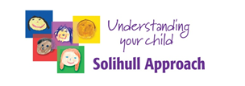
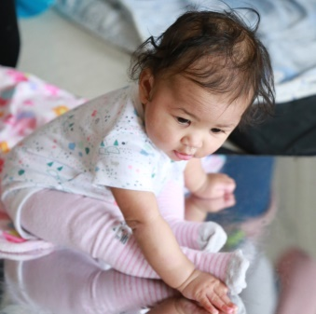

Workshop on Brain Development
Who is it for?
Parents/Carers of Babies & Toddlers living in the Southern Trust Area (This is not a practitioner’s workshop)

What does it cover?
- How the baby’s brain develops in the context of a relationship with parent/carer
- Early Social and Emotional Development
- Language Skills
- Turn Taking
- Tantrums
- Building Early Resilience

When is it on?
- January 4th or 11th or 18th or 25th
- 10am-12pm via zoom

How do I apply?
For further information or to book a place please contact
mona.hanna@southerntrust.hscni.net lisa.lenaghan@southerntrust.hscni.net
Please provide your name, contact number and the age of your child

