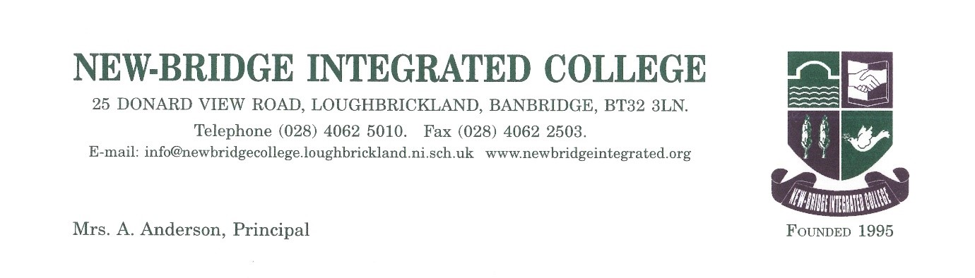

6 Jan 2023

Dear Parent/Guardian of P7 pupils at St Francis Primary School

New-Bridge Science and Technology Roadshow for St Francis Primary P7 pupils

I am delighted to report that following on from the success of our Technology Roadshow in November/December, our Science Department are offering an exciting opportunity for your son/daughter to attend our new ‘New-Bridge Science Roadshow’ after school from 3.20pm-4.20pm commencing Wednesday 11 January 2023 Our New-Bridge Roadshow is being offered to P7 students as an after-school activity, where the students will get an opportunity to focus on the following aspects in Science:

Science:
The Science department, in conjunction with Year 8 Science ambassadors, warmly welcomes P7 pupils to join our science club. Pupils will be given the opportunity to participate in practical experiments such as testing energy content in food using our Bunsen burners. You will be invited to learn about the science behind lightening and produce your own! Finally, pupils will be given the opportunity to meet our science reptiles. Our Science Roadshow will run for 4 consecutive Wednesdays starting 11 January 2023 after school and will run for 4 weeks. Transport to New-Bridge is provided and parents are asked to collect their child at 4.20pm.

We really hope that your son/daughter can attend some, if not all, of the roadshow sessions organised as our Science department are excited about teaching as aspect of their specialist area to P7s. As numbers are limited and we have a number of other schools taking part, I would ask you to complete the ‘Expression of Interest‘ form below and return to New-Bridge via email to elennon803@c2kni.net so we can finalise our numbers. Students who attended our Technology Roadshow in November /December do not need to complete a new form. Please do not hesitate to get in touch, if you have any other queries about our New-Bridge Science after school Roadshow.

Please reply by email using the Expression of Interest form provided or phone the school, if your son/daughter wishes to attend. We are very much looking forward to welcoming St Francis Primary pupils to our school once again.
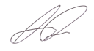
Yours sincerely
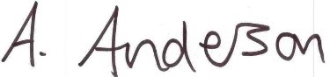

Mrs A Anderson Mr Kelly
Principal Primary Links Co-ordinator

Expression of Interest Forms

I wish to confirm that (Name of student) …………………………………………. from St Francis Primary School would be interested in attending the after school New-Bridge Science Roadshow from 3.20pm-4.20pm.

Science Roadshow
Wednesday 11 January 2023
Wednesday 18 January 2023
Wednesday 25 January 2023
Wednesday 1 February 2023

I would like my child to be transported from St Francis Primary to New-Bridge - Yes/No
I will collect my child at New-Bridge each week at 4.20pm. Yes

Contact Telephone Number ……………………………….

Parent Signature ……………………………………………………

Date…………………………..

Email: elennon803@c2kni.net
Tel: 02840625010

